
Government of Samoa
P.O. Box 1874
Apia
Samoa
Tel: (685) 22561, 22562,
22563, 22564
Fax: (685) 24576
E-mail:maffm@lesamoa.net
Please address all correspondence to the
Chief Executive Officer

Ministry of Agriculture and Fisheries

Crop Statistical Report Quarter 2, 2025

Multiplication, Distribution, Sales and Purchases of Planting Materials; Exports; Q1, 2025

1. Introduction:
The Crops Division is one of the main technical divisions of the Ministry of Agriculture and Fisheries (MAF). One of its main activities is the multiplication and distribution of planting materials to farmers, based on demand and farmer needs. Through the administrative process of multiplication and distribution, valuable information’s are collected but had not been properly captured to provide timely data for policy formulation. They were only provided on ad hoc basis.

This report is an attempt to properly organize, tabulate and analyze the information collected for user’s information and more importantly for MAF management for better policy formulation.

2. Multiplication:
Multiplication of planting materials aims to be distributed to farmers and for the MAF’s use in demonstrating plots and research.
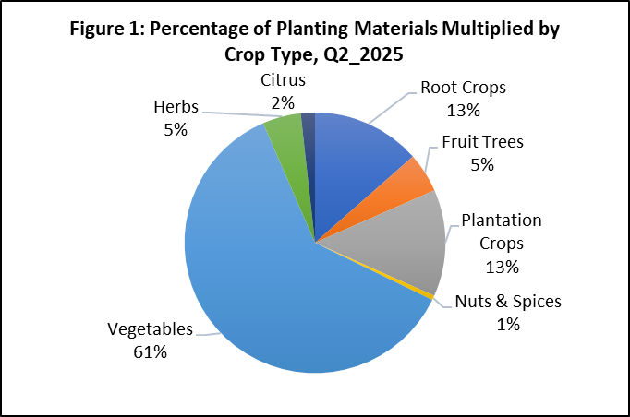

During the analyzed period, the predominant type of planting materials cultivated was Vegetables, which accounted for sixty-one percent (61%) of the total. Plantation Crops and Root Crops each made up thirteen percent (13%), while Fruit Trees and Herbs represented five percent (5%). Citrus contributed two percent (2%). The final one percent (1%) was attributed to Nuts & Spices in the specified quarter.

Taro constituted the predominant portion of planting materials multiplied within the Root Crops category, accounting for ninety-one percent (91%) during the examined timeframe, while Yam represented merely nine percent (9%). Additionally, Cocoa maintained its position as the crop with the highest proportion, at fifty-five percent (55%), for the planting materials multiplied in the plantation crops category. Furthermore, Coconut comprised forty percent (40%), while Banana accounted for three percent (3%) and Coffee only two percent (2%).

A twenty-six percent (26%) increase in the planting materials multiplied during the previous Q1 2025 was noted in comparison to Q2 2025. The table below provides a summary of the various selected crop varieties that were multiplied in Q2 of 2025.

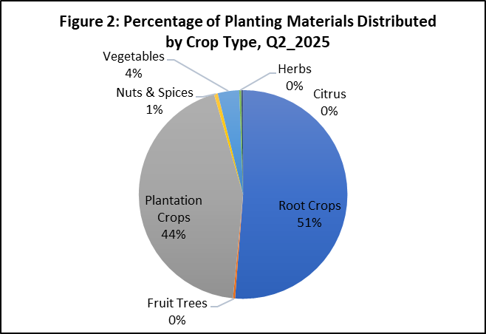
3. Distribution:
The distribution of planting materials mainly facilitated several initiatives undertaken by the Ministry. Root crops constituted the largest share of the distributed planting materials, representing fifty-one percent (51%) of the overall total. Plantation crops accounted for forty-four percent (44%), vegetables comprised four percent (4%), and the remaining one percent (1%) was allocated to nuts and spices.
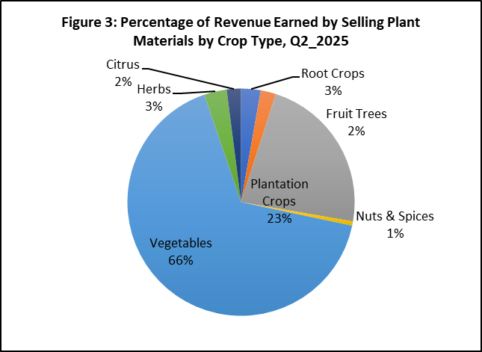
As depicted in Figure 2 above, there were no records available regarding the distribution of planting materials for other crop categories, such as Herbs; Fruit Trees and Citrus, during the specified quarter.
4. Sales and Purchases:
The planting materials that were multiplied were also made available for purchase by farmers from the main office located in Nuu and the Crops division at the Salelologa office.
Nevertheless, certain planting materials were procured from farmers to expedite the multiplication process.
The preceding Figure 3 demonstrates that the primary source of revenue was derived from the sale of vegetable planting materials, which constituted sixty-six percent (66%) of the total revenue. The sales from vegetables predominantly came from crops that command the largest market shares, such as Tomato, Cucumber, Eggplant, Chinese Cabbage, and Capsicum.
Twenty-three percent (23%) of the total sales were attributed to Plantation Crops, while Root Crops and Herbs represented three percent (3%). Citrus and Fruit Trees each contributed just two percent (2%). The remaining one percent (1%) of revenue was generated from the sale of planting materials for Nuts & Spices.

5. Export of Fresh and Frozen Taro:
Export of taro to overseas markets was recently been stimulated after the industry was affected by the taro leaf blight in the early 1990’s.
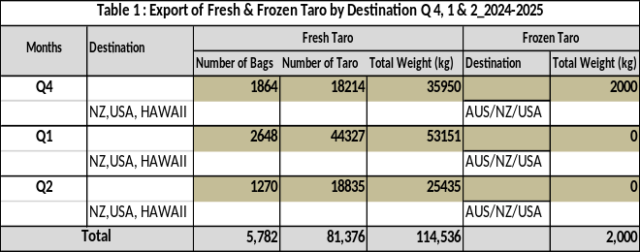
Taro destined for overseas market had to go through vigorous checks at the Atele pack house or other pack houses that were certified by MAF and other government bodies to ensure that export standards are adhered to.

The table presented above, referred to as Table 1, outlines the total number of bags and the overall weight of both fresh and frozen taro exported to various locations, including Australia, New Zealand, the United States, and Hawaii, during the first quarter of 2024 and the first and second quarters of 2025.

The export volume of fresh taro experienced a decline of forty percent (40%) when comparing the first quarter of 2025 to the second quarter of 2025. Furthermore, there were still no records documented for the export volume of frozen taro in the second quarter of 2025, mirroring the situation in the previous quarter, which was the first quarter of 2025.

6. Way Forward
The Ministry’s Agricultural Statistics Unit (ASU) will continue to assist the Crops Division staff in improving data quality and statistical skills through training. It is anticipated that ASU will produce a quarterly report in collaboration with the Crops Division which is the primary data source.

Dr Seuseu Tauati
Chief Executive Officer
Ministry of Agriculture and Fisheries

