
Government of Samoa
P.O. Box 1874
Apia
Samoa
Tel: (685) 22561, 22562,
22563, 22564
Fax: (685) 24576
E-mail:maffm@lesamoa.net
Please address all correspondence to the
Chief Executive Officer

Ministry of Agriculture and Fisheries

Crop Statistical Report Quarter 1, 2025

Multiplication, Distribution, Sales and Purchases of Planting Materials; Exports; Q1, 2025

1. Introduction:
The Crops Division is one of the main technical divisions of the Ministry of Agriculture and Fisheries (MAF). One of its main activities is the multiplication and distribution of planting materials to farmers, based on demand and farmer needs. Through the administrative process of multiplication and distribution, valuable information are collected but had not been properly captured to provide timely data for policy formulation. They were only provided on ad hoc basis.

This report is an attempt to properly organize, tabulate and analyze the information collected for user’s information and more importantly for MAF management for better policy formulation.

2. Multiplication:
Multiplication of planting materials aims to be distributed to farmers and for the MAF’s use in demonstrating plots and research.

Throughout the examined timeframe, the primary category of planting materials that were cultivated was Vegetables, representing sixty percent (60%) of the overall total. Root Crops comprised fourteen percent (14%), whereas Fruit Trees constituted twelve percent (12%). Plantation Crops accounted for seven percent (7%), which was also the case for Herbs, sharing the same percentage. There were no documented instances of Nuts & Spices during the designated quarter.

Taro accounted for the largest share of planting materials multiplied within the Root Crops category, representing seventy-eight percent (78%) during the analyzed period, while Yam accounted for twenty-two percent (22%). Moreover, Cocoa retained its status as the crop with the highest percentage, at ninety-three percent (93%), for the planting materials multiplied in the plantation crops category. Furthermore, Coconut represented three percent (3%), whereas both Coffee and Banana each held two percent (2%).

A significant reduction of fifty-six percent (56%) in the planting materials multiplied in the previous quarter (Q4 2024) was observed when compared to Q1 2025. The table below summarizes the different selected crop varieties that were multiplied during Q1 of 2025.

3. Distribution:
The distribution of planting materials was mainly in support of various projects implemented by the ministry. Root crops constituted the largest share of the distributed planting materials, making up fifty-nine percent (59%) of the total. Vegetables represented twenty-six percent (26%), Plantation Crops accounted for ten percent (10%), Fruits trees made up four percent (4%), while Herbs comprised only one percent (1%).
As demonstrated in Figure 2 above, there were no records regarding the distribution of planting materials for other crop categories, such as Nuts & Spices during the specified quarter.
4. Sales and Purchases:

Planting materials multiplied were also available for sales to farmers from the main office at Nuu and the Crops division at the Salelologa office.
However, some planting materials were bought from farmers to accelerate the multiplication process. s
The preceding Figure 3 illustrates that the predominant source of revenue originated from the sale of Vegetables planting materials, accounting for sixty-six percent (66%) of the overall total. Sales of Vegetables was mainly derived from the crops with the largest shares, such as Eggplant, Green Pepper, Tomato, Cucumber, and Lettuce.
Seventeen percent (17%) of total sales originated from Plantation Crops, while Fruit Trees contributed eleven percent (11%), Herbs made up three percent (3%), and Root Crops accounted for just two percent (2%). The remaining one percent (1%) of revenue was produced from the sale of planting materials for Nuts & Spices.
5. Export of Fresh and Frozen Taro:
Export of taro to overseas markets was recently been stimulated after the industry was affected by the taro leaf blight in the early 1990’s.
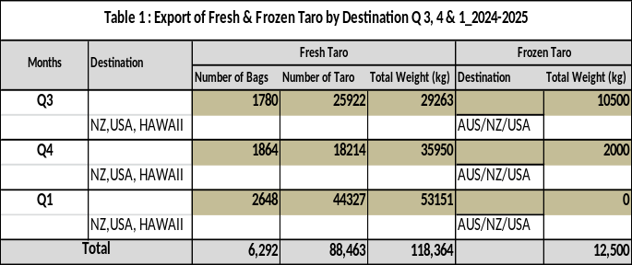
Taro destined for overseas market had to go through vigorous checks at the Atele pack house or other pack houses that were certified by MAF and other government bodies to ensure that export standards are adhered to.

The table above, labeled as Table 1, details the total quantity of bags and the cumulative weight of both fresh and frozen taro exported to various destinations, including Australia, New Zealand, the United States, and Hawaii, during the last two quarters of 2024 and the initial quarter of 2025.

The export volume of fresh taro saw an increase of forty-two percent (42%) when comparing the fourth quarter of 2024 to the first quarter of 2025. Additionally, there were no records reported for the Export Volume of Frozen Taro in the designated quarter.

6. Way Forward
The Ministry’s Agricultural Statistics Unit (ASU) will continue to assist the Crops Division staff in improving data quality and statistical skills through training. It is anticipated that ASU will produce a quarterly report in collaboration with the Crops Division which is the primary data source.

Dr Seuseu Tauati
Chief Executive Officer
Ministry of Agriculture and Fisheries

